How to use MASM611 in windows 64-bit
1) Run the DOSBox.exe file and install it like any other software.
Now that you’ve installed DOSBox, you’ll be able to run any 16bit or 32bit DOS executable inside it.

2) Paste the ‘8086’ folder in c:\
8086 folder contains the files
masm.exe, tasm.exe, link.exe, bin2hex.exe, exe2bin.exe, td.exe, edit.com and debug.exe, ml.exe

3) Launch DOSBox and type the following commands :
mount c c:\8086
c:
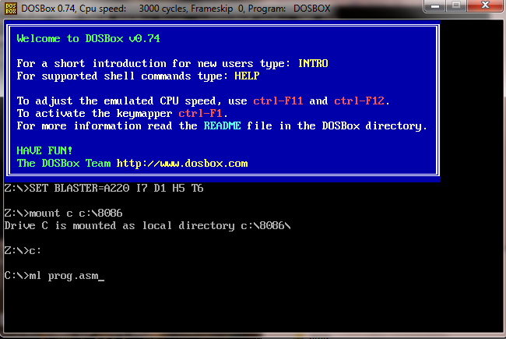

Now you are in c:\8086 directory.
Note: make .asm programs in c:\8080 directory. For example “prog.asm” is already in this directory.
Now use the same commands you use for making, compiling, linking and debugging (edit, ml, masm, link, debug).

